5. GOVERNOR
Governor is a feedback device which regulate the fuel supply, whenever there is variation in output load. | Fuel Supply | Throttling Vale | Prime Mover | Load
 | Feedback Device
- If Load $↑$, $ω↓$, Throttle valve opens, Fuel supply $↑$.
- For some change in load, the fluctuation in speed of gov. “A” is smaller than that of gov. “B”. Hence, Gov. “A” is better than “B”.
FLYWHEEL | GOVERNOR
It is a reservoir of energy. | It’s a feedback device.
Flywheel has no control over the mean speed. | It can change the mean speed of prime mover.
It can’t change the fuel supply. | It can change the quality as well as quantity of the fuel supply.
It controls the fluctuation with in the cycle (Intra cycle fluctuation). | It controls the fluctuation between two consecutive cycle (Inter cycle fluctuation).
Flywheel is continuously working device. | It is an intermittent working device.
If supply & load are uniform, the flywheel is not required. | It is a compulsory device for all prime movers.

CLASSIFICATION OF GOVERNOR (BASED ON FORCE)
CENTRIFUGAL GOVERNOR |  |  | INERTIA GOVERNOR
Pendulum Type | Loaded Type
Watt Governor | Gravity Controlled | Spring Controlled
1st Generation Governor: Watt Governor, Porter, Proell, Hartnell. These are in our syllabus.
GRAVITY CONTROLLED |  | SPRING CONTROLLED
Porter | Proell | Hartnell | Welson | Hartung | Pickring (Used in Gramophone)
- ANALYSIS OF WATT GOVERNOR:
- Sleeve of watt governor is massless.
- Inertia of arm is negligible.
TYPE OF WATT GOVERNOR:

- Simple
- Open arm
- Closed or Cross arm

HEIGHT OF GOVERNOR ($h$): It’s the distance between the Plane containing governor ball to the point where upper arms are intersecting with the governor axis either by their own or extended.
LIMITATIONS OF WATT GOVERNOR: The variation of $“h”$ was appreciable for low value of $“N”,$ for high speed the variation in $“h”$ is very small due to which the governor becomes insensitive corresponding to high speed. Hence, the working range of the governor is less. Here, $\tan{θ}=r/h$
Taking moment about “I”,  $$mg ID-mrω^{2} BD=0$$  $$ω^{2}=\frac{g}{r} \frac{ID}{BD}=\frac{g}{r}\tan{θ}=\frac{g}{h}$$ | $$ω=\frac{2πN}{60}, Where N=RPM$$  $$N^{2}=\frac{895}{h}$$ | Here, $ω^{2}h=g=Constant=Hyperbolic$ From this equation Limitation can be derived as sensitivity decreases with increase in speed.

- ANALYSIS OF PORTER GOVERNOR:
$m=$ Mass of Governor Balls,  $M=$ Mass of Sleeve,  $f=$ Friction force between sleeve and spindle,  $e=$ eccentricity of lower arm and governor axis,  Taking moment about “I”,  $$mg c+\left(\frac{Mg±f}{2}\right)\left(c+b\right)-mrω^{2} a=0$$  $$∴mrω^{2}= mg \frac{c}{a}+\left(\frac{Mg±f}{2}\right)\left(\frac{c+b}{a}\right)$$  $$∴mrω^{2}=mg\tan{θ}+\left(\frac{Mg±f}{2}\right)\left(\tan{θ}+\tan{β}\right)$$  Here, $\tan{θ}=r/h.$Let, $K={\tan{β}}/{\tan{θ}}$  $$ω^{2}=\frac{2mg+\left(Mg±f\right)\left(1+K\right)}{2mh}$$ | 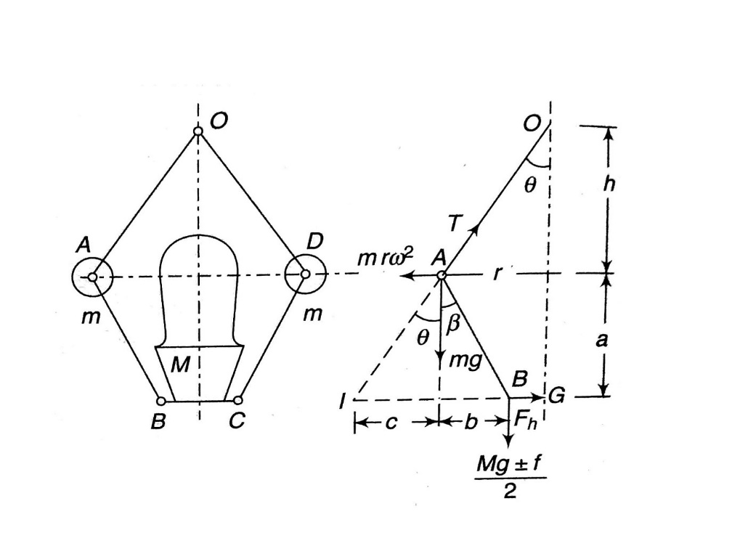
CASE-I: If $K=1$, $θ=β$. Hence, the length of upper and lower arms should be same and the eccentricity of both arms should also be same. |  | $$ω^{2}=\frac{mg+\left(Mg±f\right)}{mh}$$
If $f=0$(Friction between sleeve and spindle is zero)
$$ω^{2}=\left(\frac{m+M}{m}\right)\frac{g}{h}=\frac{Weight of ball+Weight of Sleeve}{mh}=\left(\frac{m+M}{m}\right)ω_{Watt}^{2}$$
Hence, Porter governor can used at higher speed than watt governor.
GOVERNOR TERMINOLOGY:
- Centrifugal Force $\left(F_{C}\right)$:$F_{C}=mrω^{2}$. It increases the radius of rotation. For each $ω$, There will be a unique Straight line for $F_{C} Vs.r$ Graph. Because $\tan{θ}= mω^{2}$
- Controlling force ($F(r)$): It’s the resultant of all the forces which regulate the movement of governor ball E.g. Weight of balls, Weight of Sleeve, friction force, friction between different elements.
- In spring-controlled governors, Spring force & in gravity-controlled governors, weight of the sleeve is major constituent of controlling force.
- Controlling force is always acting towards the gov. axis. Therefore, it’s tendency is to reduce the radius of rotation.
- For an Active/ Working governor, $F\left(r\right)>0$ always. And at equilibrium $F\left(r\right)=F_{C}=mrω^{2}$
For Gravity Controlled Governor,  $$\begin{matrix}Slope of F\left(r\right) vs r \\ at any point\end{matrix}=\begin{matrix}Slope of tangenet to \\ the curve at same point\end{matrix}=\frac{F\left(r\right)}{dr}$$ | For spring-controlled Governors, $F\left(r\right)=ar+b, Where a,b$ are constant and depends on the BCs.
- Types of Equilibrium:
- Stable Equilibrium: If the system returns to the initial equilibrium position by it’s own, whenever disturbed from there, it’s called as Stable Equilibrium.
- Unstable Equilibrium: If the system does not return to the initial position by it’s own, whenever disturbed from there, it’s called as Unstable Equilibrium. For this system, we need to do work on the system to bring it back to initial Stable Equilibrium position.
- Neutral Equilibrium: If the system always remains in equilibrium, it’s called Neutral Equilibrium. To bring the system back at initial equilibrium position, work need to be done on the system.
NOTE: Work required to bring the system back to the initial equilibrium position is more in case of unstable equilibrium than the neutral equilibrium.
STABILITY OF GRAVITY-CONTROLLED GOVERNORS:
- Condition for stable governor:
$$\begin{matrix}Slope of F\left(r\right) Vs. r \\ curve at Eq. Position\end{matrix}>\begin{matrix}Slope of F_{C} Vs. r \\ Line at Eq. Position\end{matrix}$$ | $$\frac{dF\left(r\right)}{dr}>\frac{F_{C}}{r}$$ | $$@r_{eq.}, ∅>θ$$
NOTE:
- The graph for $F\left(r\right) Vs. r$ and $F_{C} Vs. r$ can not interesct at more than one location. so, there cannot be one $ω$ at two different radius of rotation. Hence, for each $ω$ there will be a unique radius of rotation.
- For stable governor, Radius of rotation increases with increase in the rotational speed. That can be concluded from the Graph $F\left(r\right) Vs. r$ and $F_{C} Vs. r$ and it’s intersection at different $ω$.
- Condition for Unstable governor:
$$\begin{matrix}Slope of F\left(r\right) Vs. r \\ curve at Eq. Position\end{matrix}<\begin{matrix}Slope of F_{C} Vs. r \\ Line at Eq. Position\end{matrix}$$ | $$\frac{dF\left(r\right)}{dr}<\frac{F_{C}}{r}$$ | $$@r_{eq.}, ∅<θ$$  $$∅=\tan^{-1}{a}$$
- If a governor is stable at particular radius, then the governor will be stable throughout it’s working range.
STABILITY OF SPRING-CONTROLLED GOVERNORS:
- Condition for stable governor: Same condition like previous  For active governor, $F\left(r\right)>0⇒ar_{min}-b>0⇒r_{min}>b/a$  - Condition for Unstable governor: Same condition like previous  - Condition for Isochronous governor: It’s neutral equilibrium condition.  $r_{i}≠r_{j}$ but $ω_{i}=ω_{j}=ω=Constant.$  Radius may change at constant speed which is not possible. |  |  |  | 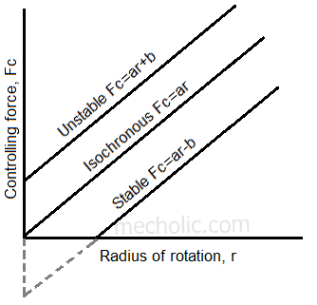
$$F\left(r\right)$$ | $$a$$ | $$b$$
$$F\left(r\right)= ar+b$$ | $$+ve$$ | $$+ve$$ | Unstable
$$F\left(r\right)= ar-b$$ | $$+ve$$ | $$-ve$$ | Stable
$$F\left(r\right)= ar$$ | $$+ve$$ | $$0$$ | Isochronous
An unstable governor will become isochronous if we reduce the controlling force and if the controlling force is further reduced than it will become stable.
SENSITIVENESS OF GOVERNOR: It is the ability of a governor to sense the change in operating load and change in the fuel supply. $Sensitivity∝{Stability}^{-1}$
CASE-I: When the governor is an independent mechanism. E.g. not connected to prime mover. In this case sleeve displacement will be large corresponding to frictional change in speed.  $$Coeff. of Sensitivity=\frac{Mean Speed}{Range of Speed}$$ | CASE-II: When the governor is connected to prime mover. In this situation, objective of the governor is to minimise the speed fluctuations of prime mover even if the load changes from full to no load.  $$Coeff. of Sensitivity=\frac{Range of Speed}{Mean Speed}$$
$$Range of Speed=ω_{max}-ω_{min}$$ | $$Mean Speed={\left(ω_{max}+ω_{min}\right)}/2$$
HUNTING OF GOVERNOR: Due high sensitivity, the prime mover/ Sleeve will fluctuate about it’s mean position. In other words, Due high sensitivity, the prime mover will fluctuate about it’s mean speed. This phenomenon is known as hunting of governor. Due to this hunting there will be random violent oscillation will occur at natural frequency of vibration. And resonance will occur.
For Isochronous governor, $ω=Constant.$ This is theoretical governor and can’t be used practically. So, the Sensitivity of the governor is infinite, when it’s independent mechanism. And the Sensitivity of the governor is zero, when it’s used with any prime mover.
COMPARISON OF TWO DIFFERENT STABLE GOVERNOR:
For same change in speed, the change in radius of governor 1 is larger than that of governor 2. Therefore, for same change in speed, the sleeve displacement of governor 2 will be smaller than that of governor 1. So, governor 2 is more stable and less sensitive.
- Coefficient of insensitiveness or effect of friction on governor:
NOTE: At equilibrium condition, friction in the sleeve is zero.
CASE-I: Let there is no friction between sleeve and spindle. Governor is fully sensitive.
CASE-II: Let there is friction between sleeve and spindle When speed is changed from the equilibrium speed. Governor is insensitive due to friction for small range of speed.
Change in speed required to overcome friction $=ω_{1}-ω=ω-ω_{2}$  $$ω=\frac{ω_{1}+ω_{2}}{2}$$ | Coefficient of insensitiveness,  $$C_{I}=\frac{ω_{1}-ω_{2}}{ω}=2\left(\frac{ω_{1}-ω_{2}}{ω_{1}+ω_{2}}\right)$$
Where, $ω=$ Speed at which there is no friction between sleeve and spindle.
$ω_{1}=$ Speed at which sleeve is about to move in upward direction E.g. Corresponding to $Mg+f$
$ω_{2}=$ Speed at which sleeve is about to move in down direction E.g. Corresponding to $Mg-f$
Friction always make the governor insensitive over a small range of speed.
- Governor effort and power:
GOVERNOR EFFORT: It’s Mean force responsible for sleeve displacement. Or Force required to bring 1% change in speed of prime mover. At equilibrium position, $Governor effort=0$
$$Governor effort=F_{mean}=\frac{0+F}{2}=\frac{F}{2}$$
Sleeve displacement $\left(x\right)$  $$x=\left[AB\cos{θ}+BC\cos{β}\right]-\left[AB^{'}\cos{θ^{'}}+BC^{'}\cos{β^{'}}\right]$$ | If $θ=β,$ $AB\cos{θ}=BC\cos{β}=h$ &  $$B^{'}\cos{θ^{'}}=BC^{'}\cos{β^{'}}=h^{'}$$
$$x=2\left(h-h^{'}\right)=2 Change in height of governor$$
$$h=\frac{2mg+\left(Mg±f\right)\left(1+K\right)}{2mω^{2}}\left(\begin{matrix}For Portor \\ Gov.\end{matrix}\right)⋯\left(1\right)$$ | $$h^{'}=\frac{2mg+\left(Mg±f\right)\left(1+K^{'}\right)}{2m{ω^{'}}^{2}}⋯\left(2\right)$$
Let, $ω^{'}=\left(1+C\right)ω$ , $K^{'}=K$ , $0≤C≤1$  Neglecting higher order terms of $C$ . | $$h=\frac{2mg+\left(Mg±f+F_{mean}\right)\left(1+K\right)}{2m{ω^{'}}^{2}}⋯\left(3\right)$$
From $\left(1\right)$ & $\left(3\right)$,  $$F_{mean}=\frac{2C}{1+K}\left[2mg+\left(Mg±f\right)\left(1+K\right)\right]=\frac{F}{2}$$ | If $K=1$, $F_{mean}=F/2=C\left[mg+\left(Mg±f\right)\right]$  If $f=0$, $F_{mean}=F/2=C\left[mg+Mg\right]$
POWER OF GOVERNOR $\left(P\right)$: Work done by effort is known as power of governor.
$$P=F_{mean}*x=\frac{F}{2}x=C\left[m+M\right]g 2h\left(1-\frac{1}{1+2C}\right)$$  $$P=\frac{4C^{2}}{1+2C}\left[m+M\right]gh\left[∵\begin{matrix}neglecting higher \\ order terms of C\end{matrix}\right]$$ | For $θ=β, f=0$,  $$x=2h\left(1-\frac{h^{'}}{h}\right), h=\frac{\left(M+m\right)g}{mω^{2}}, h^{'}=\frac{\left(M+m\right)g}{m{ω^{'}}^{2}}$$

HARTNELL GOVERNOR:
When ball arms are vertical & Parallel to the governor axis. Taking moment about fulcrum “O”,  $$mrω^{2}x= \left(\frac{Mg+F_{S}}{2}\right)y⋯\left(1\right)$$  Taking moment about point “O” at $ω_{1}$,  $$mr_{1}ω_{1}^{2} x\cos{θ_{1}}+mg C_{1}= \left(\frac{Mg+F_{S1}}{2}\right)y\cos{θ_{1}}⋯\left(2\right)$$  Taking moment about point “O” at $ω_{2}$,  $$mr_{2}ω_{2}^{2} x\cos{θ_{2}}+mg C_{2}= \left(\frac{Mg+F_{S2}}{2}\right)y\cos{θ_{2}}⋯\left(3\right)$$  Let $θ_{1}\& θ_{2}$ are very small. E.g. let the ball arms remains vertical and sleeve arm remains horizontal.  $x\cos{θ_{1}}=x\cos{θ_{2}}=x$ &$y\cos{θ_{1}}=y\cos{θ_{2}}=y$ & $C_{1}=C_{2}=0$ |  | 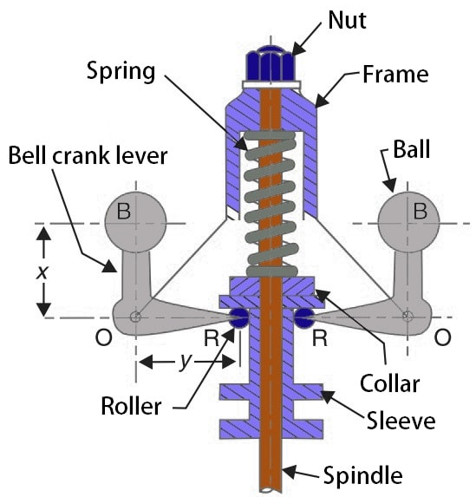
$$mr_{1}ω_{1}^{2} x= \left(\frac{Mg+F_{S1}}{2}\right)y⋯\left(4\right)$$ | $$mr_{2}ω_{2}^{2} x= \left(\frac{Mg+F_{S2}}{2}\right)y⋯\left(5\right)$$ | $$\frac{F_{C1}}{F_{C2}}=\frac{r_{1}ω_{1}^{2}}{r_{2}ω_{2}^{2}}=\frac{Mg+F_{S1}}{Mg+F_{S2}}\left[∵4/5\right]$$
$$\left[F_{C1}-F_{C2}\right]x=\frac{F_{S1}-F_{S2}}{2}y\left[∵4-5\right]$$ | $${\left(F_{S}\right)}_{Net}=F_{S1}-F_{S2}=kd$$ | From the similar triangles in the fig.  $${\left(r_{1}-r_{2}\right)}/d=x/y$$
$$k=2\frac{{\left(F_{S}\right)}_{Net}}{r_{1}-r_{2}}{\left(\frac{x}{y}\right)}^{2}$$

Condition for isochronism,  $$\frac{F_{C1}}{F_{C2}}=\frac{r_{1}}{r_{2}}=\frac{Mg+F_{S1}}{Mg+F_{S2}}$$ | If sleeve mass is neglected at isochronism,  $$\frac{F_{C1}}{F_{C2}}=\frac{r_{1}}{r_{2}}=\frac{F_{S1}}{F_{S2}}$$

